A Qualitative Approach to Noise Treatment and Acoustic Comfort

Ing. arch. Šimon Prokop

Background noise and room ambience
What is constantly surrounding us in any built environment? Sound. The ambience of the room we dwell in. Each room has a different one and architects still struggle to realize that it affects our perception of space and our comfort.
When we work, certain level of concentration is needed to perform tasks efficiently without unnecessary fatigue. Room background noise and other introduced noises have a huge impact on our concentration. A substantial body of research talks about noise levels and matches them with statistical data to prove that noisy environments have health consequences. [1] However, qualities of the noise present are simplified usually to only two categories – impulse noises and constant noises. The same does the Czech legislative for example.
Sound is very delicate and there is a lot of “information” in the whole audible spectrum. Sometimes the noisiness of a workplace is almost untreatable or the costs of treatment outweigh the potential betterment. Is playing the radio loudly over the noise the only viable solution? What if there is a way of treating such noise using sound masking and generative music approaches?

Classification of noises
Sound in general affects humans in four ways: physiologically, psychologically, cognitively and behaviorally. Not only the acoustic pressure level, but our relationship with the sound and understanding of its origin has also impact on the way we perceive it.
A lot of effects of noise on the cognitive performance might be deeply subjective, however there are commonalities rooted in psychoacoustics and our physiology. Some noises are helping to sleep or concentrate, on the other hand, some are intrusive and break concentration, induce stress and damage sleep patterns.
Every room has its own background noise (ventilation, appliances, chatter…) which mixes with external noises (traffic outside, wind blowing, rain…). The resulting soundscape usually has a few constant elements (fans, devices…) and a few dynamic ones (traffic, chatter, random events, people coughing…). Each component of such soundscape has different frequencies and timespans which all add up. What are the qualities that make certain noise beneficial and which cause damage over time?

Textural and recognizable noises
According to Julian Treasure understanding which sound source is responsible for a noise can make a huge difference in making decision whether the noise is intrusive or not. [2] This decision is quite often done on a subconscious level, however not always.
The context of the noise also should be taken in account since we still exhibit signs of internal programming from prehistoric ages. One example could be the soothing effect of birdsong. When we hear such noises we automatically associate them with feelings of being safe because birds only sing when no predators are detected. It is possible early humans noticed this and used that for additional safety and it is still present to some degree.

Obtrusive sounds
Another type of noise is usually created by electronic devices and appliances which produce unwanted constant pitches or bands of frequencies. Similar noises can be produced by fans and ventilation or air conditioning. These usually high-pitched tones pierce through the ambient noise and are hard to suppress even with some conscious effort.

White, pink and brown noise
The most popular noise recordings people willingly listen to are mostly comprised of combinations of white, pink and brown noises. Each of those shows a flat frequency distribution over longer time span and resembles sound of a waterfall in a distance with varying accent on higher frequencies. The most popular sounds also mix in some element of subtle (musical) movement over a period of approximately 2 minutes, so that the resulting soundscape isn’t too repetitive or constant. The more even amplitudes a noise has over the audible spectrum, the more popularity it attracts.

Treating a noisy environment
That all means there might be a commonly acceptable background noise which will be beneficial to anyone. This work will attempt to find a way to produce such noise qualities and test its performance in different contexts and with different people. However just playing a noise track will produce an unnecessarily high levels of acoustic pressure. The aim here is to find a match between an activity, space and additional masking noise. In order to minimize the acoustic pressure increase, a real-time generative approach will be used.
Ever-present background noise blends with external noises and noises introduced by actions taking place in a space into an ambient soundscape. In order to turn such a soundscape into something beneficial and inobtrusive a microphone array is needed to capture the sound field because the amplitudes will be of a varying strength at different places. Then an array of speakers will counterbalance the dynamic noises in real time as well as the static noises present in the room in order to establish a soundscape with as flat frequency distribution as possible.
A closely related approach is currently being used in noise canceling headphones with a difference that the output is fed just to a pair of speakers and therefore phase cancelation can be used if the processing speed is fast enough to produce reverse phase waves. This approach is not applicable in open space leaving only sound masking as a viable approach.

Aural Comfort

The main health hazards of noise stem from long-term continuous unconscious noise suppression which can be associated with increased stress levels and is usually also correlated with increases in heart rate. [3] Transforming the noise into a more bearable might remedy this and even turn an ambient noise into a soothing soundscape. This work aims to contribute to finding a better definition of aural comfort in order to battle the effects of noise.

References
[1] Louis, R. & Mark, D. 2020, "Indicators of Healthy Architecture—a Systematic Literature Review", Journal of urban health, vol. 97, no. 6, pp. 899-911.
[2] Treasure, J. 2010, Sound business: How to use sound to grow profits and brand value (2nd ed.). Management Books.
[3] Vandasova, Z., Vencálek, O. & Puklová, V. 2016, "Specific and combined subjective responses to noise and their association with cardiovascular diseases", Noise & health, vol. 18, no. 85, pp. 338-346.Figures

Figures

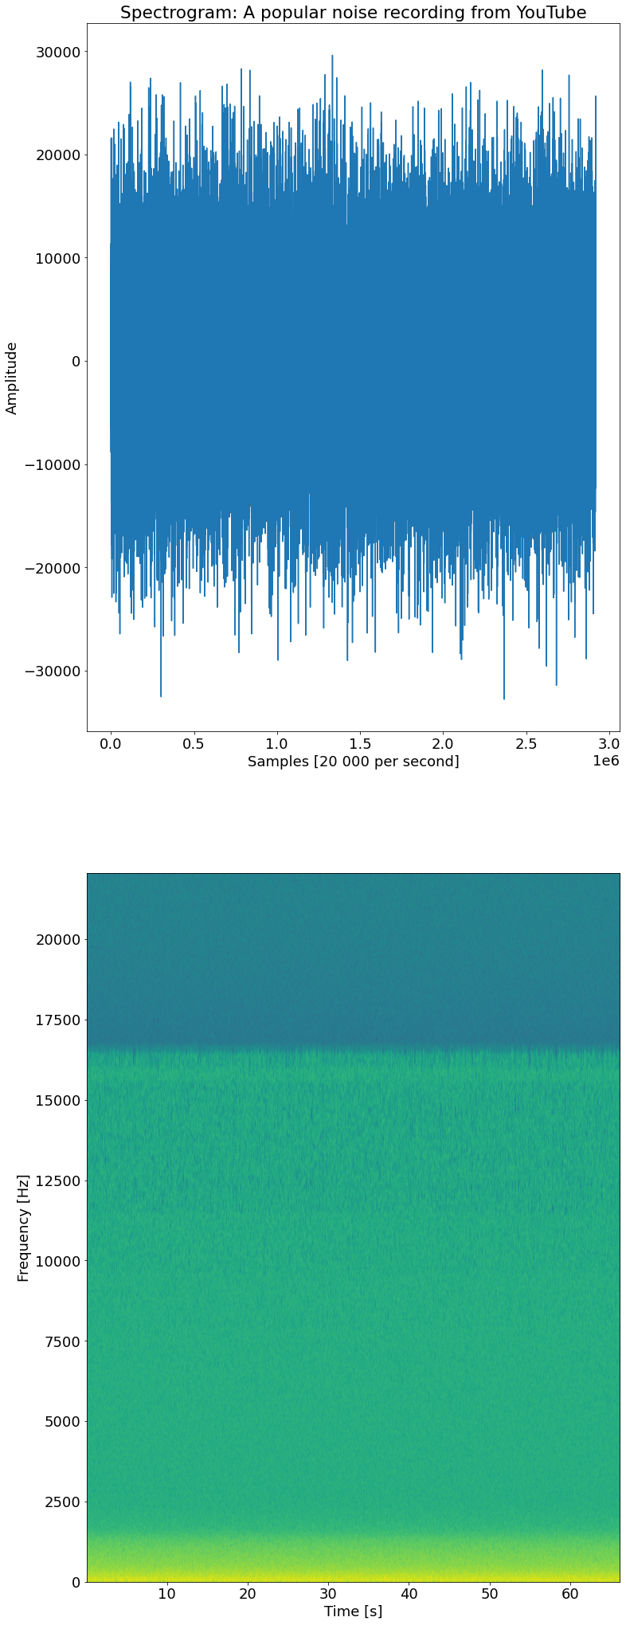
Fig. 1: Evenly distributed frequencies over time of a popular noise track
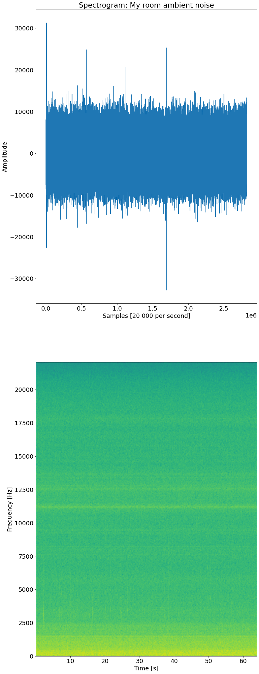
Fig. 2: Horizontal frequency bands of constant obtrusive noise in a room

